AppInventor

What is App Inventor?
App Inventor lets you develop applications for Android phones using a web browser and either a connected phone or emulator. The App Inventor servers store your work and help you keep track of your projects.

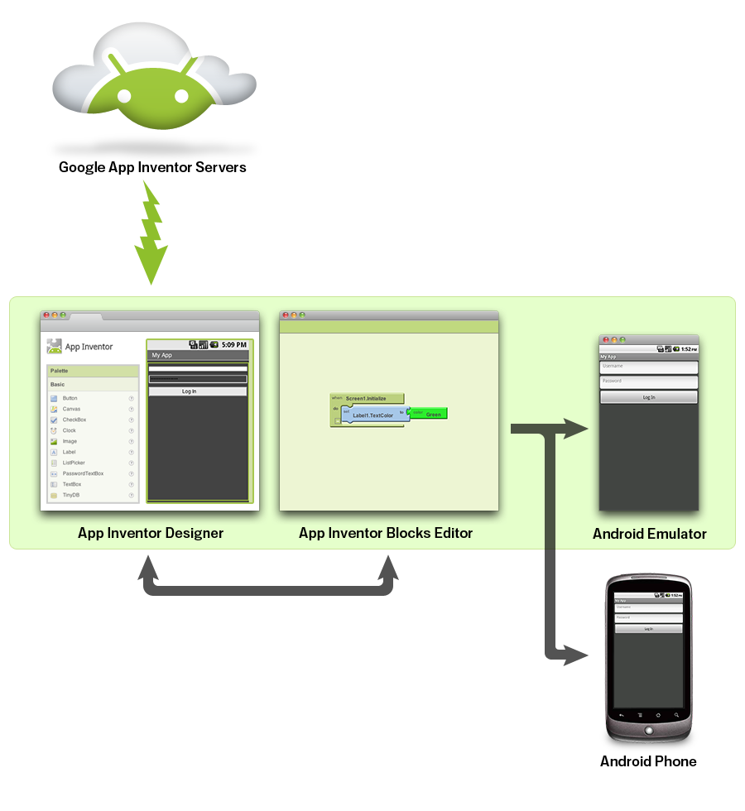
You build apps by working with:
- The App Inventor Designer, where you select the components for your app.
- The App Inventor Blocks Editor, where you assemble program blocks that specify how the components should behave. You assemble programs visually, fitting pieces together like pieces of a puzzle.
- Screen shots with explanations can be found at http://appinventor.mit.edu/explore/designer-blocks.html

Your First App

HelloPurr

Design the Screen
- Go to the AppInventor2 site: http://ai2.appinventor.mit.edu/
- Create a new project and call it HelloPurr
- Click on Learn and choose Hello Purr
  - Right-click on the Kitty Picture and save the link
  - Right-click on the Meow sound and save the link
- Return to the AppInventor site. You can return to the detailed HelloPurr instructions at any time.
  - Add a button to the designer window and change the button properties as follows:
    - Button image to kitty.png
    - Clear the button text
    - Change the button width to ‘Fill Parent’
    - Change the button height to ‘Fill Parent’
  - Add a label under the image and change its properties
    - Font size = 30
    - Text colour to yellow
    - Background colour to blue
  - Add some Media – Sound
    - Change the sound property to the meow sound

Handle Events
- Open the Blocks Editor – save the ‘jnlp’ file and then run it
  - WAIT
  - Select MyBlocks from the palette and find the button click EVENT. Drag this block onto the editor
THIS IS AN EVENT HANDLER
  - When the App is running and thebutton is clicked, we want the COMMAND play sound to execute. Drag this block inside the EVENT HANDLER block.
- Save the App. It’s complete!

GREEN BLOCKS ARE EVENT HANDLERS

PURPLE BLOCKS ARE COMMANDS

Send the App to the Phone Emulator
- In the Blocks Editor select ‘New Emulator’
  - WAIT, WAIT, WAIT. Swipe the phone screen when you can see it.
  - Back to the Blocks Editor and select ‘Connect to Device’. The device is Emulator – 5554
- When the cat appears on the phone screen, the App is running! Click on the screen

Exercises
- Find a different sound and use this instead of the Meow. Any mp3 will do.
- Find another image of similar size ( about 294 x 270 pixels ) and replace Kitty
- Change the screen title from Screen 1 to Cute Kitty
- As well as playing a sound when the ‘button’ is clicked, get the phone to vibrate.
- Get the App to handle another event (add another event to the Blocks Editor. Get the cat to purr when the phone is shaken.

