Kaiser Chiefs Lyrics – “Ruby”
[Verse 1:]
Let it never be said
The Romance is dead
'Cause there's so little else
Occupying my head
[Verse 2:]
There is nothing I need
except the function to breathe
But I'm not really fussed
Doesn't matter to me
[Chorus]
[Verse 3:]
Due to lack of interest
Tomorrow is canceled
Let the clocks be reset
And the pendulums held
[Verse 4:]
'Cause there's nothing at all
Except the space in-between
Finding out what you're called
And repeating your name
[Chorus]
[Middle 8:]
Could it be, could it be
That you're joking with me?
And you don't really see you and me [x2]
[Chorus]
Do you, do you, do you, do you
Know what you're doing, doing, to me
https://www.youtube.com/watch?v=qObzgUfCl28
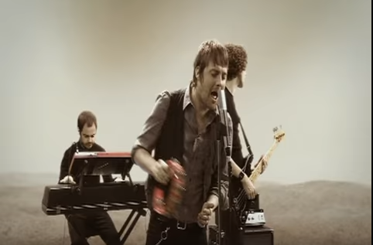
[Chorus:]
Ruby, Ruby, Ruby, Ruby
Do you, do you, do you, do you
Know what you're doing, doing, to me
Ruby, Ruby, Ruby, Ruby

Old MacDonald had a farm
Old MacDonald (animal, noise)
Old MacDonald had a farm
E-I-E-I-O
And on his farm he had a [animal]
E-I-E-I-O
With a [noise] [noise] here
And a [noise] [noise] there
Here a [noise], there a [noise]
Everywhere a [noise] [noise]
Old MacDonald had a farm
E-I-E-I-O

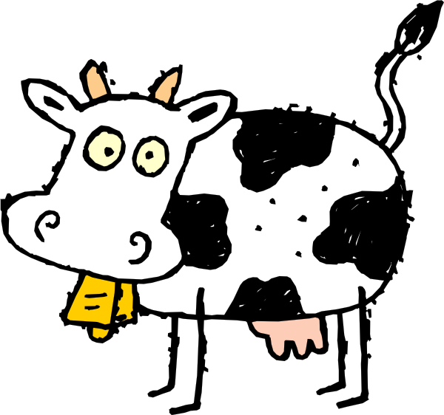

Old MacDonald (cow, moo)
Old MacDonald (pig, oink)
Old MacDonald (duck, quack)
Old MacDonald (horse, neigh)
Old MacDonald (lamb, baa)
Old MacDonald (chicken, cluck)
Old MacDonald had a farm
E-I-E-I-OOOOOOO.........

