Networking

Computer Network

When two or more ………. are connected together through a communication medium, this can be described as a network. The purpose of connecting them together is to share data, information and ………… .

Network Components

Servers
- A server is a computer ……….. that provides services to other …….. programs (and their users) on the same or other computers.
- The computer that a server program runs on is also frequently referred to as a ……. (though it may be used for other purposes as well).
- In the client/server programming model, a server is a program that awaits and …….. requests from …….. programs in the same or other computers. A given application in a computer may function as a client with requests for ……….. from other programs and also as a server of requests from other programs.
Specific to the Web, a … ……… is the computer program (housed in a computer) that serves requested Hypertext ………. ……….. pages or files to a Web Client. A Web client is the requesting program associated with the user. The Web browser in your computer is a client ……… that requests HTML files from Web servers.

Clients

Clients are programs that use the ………… that a server provides. Generally computers running client software are less powerful than computers running server software.

Client/Server Model

Client/server describes the relationship between two computer programs in which one program, the client, makes a service request from another program, the server, which fulfils the request. Although the client/server idea can be used by programs within a single computer, it is a more important idea in a network. In a network, the client/server model provides a convenient way to interconnect programs that are distributed efficiently across different locations. Computer transactions using the client/server model are very common. For example, to check your bank account from your computer, a client program in your computer forwards your request to a server program at the bank. That program may in turn forward the request to its own client program that sends a request to a server at another bank computer to retrieve your account balance. The balance is returned back to the bank data client, which in turn serves it back to the client in your personal computer, which displays the information for you.
The client/server model has become one of the central ideas of network computing

Means of Network Connection

For computers to be connected they require a communication medium such as cable, wireless signal or the internet. There has to be an interface between the client computer and this medium and between the connecting medium and the server computer. This is called the …………. …………… or Network Interface.

Resources (Peripherals)

A peripheral is any computer ……… that is not part of the essential computer (the processor, memory, and data paths) but is situated relatively close by. Some peripherals are mounted in the same case of the client computer such as the …. …. and ….. …….. drive. Other peripherals are outside the computer case, such as the printer and image …………, attached by a wired or ………… connection and can be either local devices or network resources.

User (End User)

Anyone using a client computer to access network resources is referred to as a User or End User.

Protocols

eMail protocols
SMTP – Simple Mail Transfer Protocol is used for sending email.
POP – Post Office Protocol is used for receiving email. This is now more usually POP3 because it is now settled on the third version of this protocol.

Web Protocols
HTTP – Hypertext Transfer Protocol is used to transmit HTML pages / web pages.
HTTPS – This is HTTP over Secure Socket Layer. This uses encryption to make transmission more secure.
FTP – File Transfer Protocol is used to copy files from one computer to another over a network. This is usually encountered when uploading files between a web server and client.

IP Layer in TCP/IP
A communications protocol is a system of digital rules for message exchange within or between computers. This can be thought of as the languages used for computers to communicate. Some common protocols are:
- TCP - The Transmission Control Protocol is a way of breaking up information into smaller ………… for transmission and then reconstructing them at the other end. This information forms a part of the Header, at the front of each data segment.
- IP –The Internet Protocol is used to identify the …… and the recipient using their unique IP ………… . This is also added to the packet Header to become an IP Datagram.
These two protocols are often referred to as one process, or layer, the TCP/IP layer.

When these packets are passed to the network adaptor, the Ethernet layer adds its information to the packet header, it adds a footer and then the packet is transmitted.

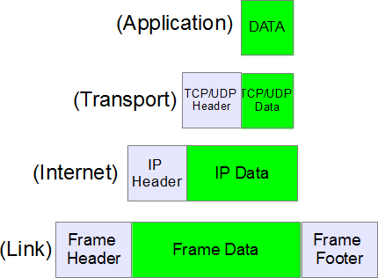

The constituent Parts of an IP Header

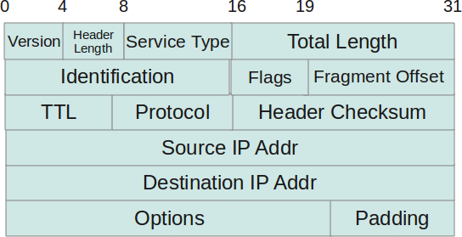

What is Checksum?

A check sum is a value that is computed from the data packet to check its ………. . Through integrity, we mean a check on whether the data received is error free or not. This is because while traveling on network a data ……….. can become corrupt and there has to be a way at the receiving end to know that data is corrupted or not. This is the reason the checksum field is added to the ………. . At the source side, the checksum is calculated and set in header as a field. At the destination side, the checksum is again calculated and ………………… with the existing checksum value in header to see if the data packet is OK or not.

CD-ROM
Address
Client
Computer
Computers
Crosschecked
Device
Fulfils
Hard Disk
Header
Integrity
Network Adaptor
Packet
Pieces
Program
Program
Resources
Scanner
Sender
Server
Services
Web Server
Wireless

