**Screenshots for magic 8 ball**

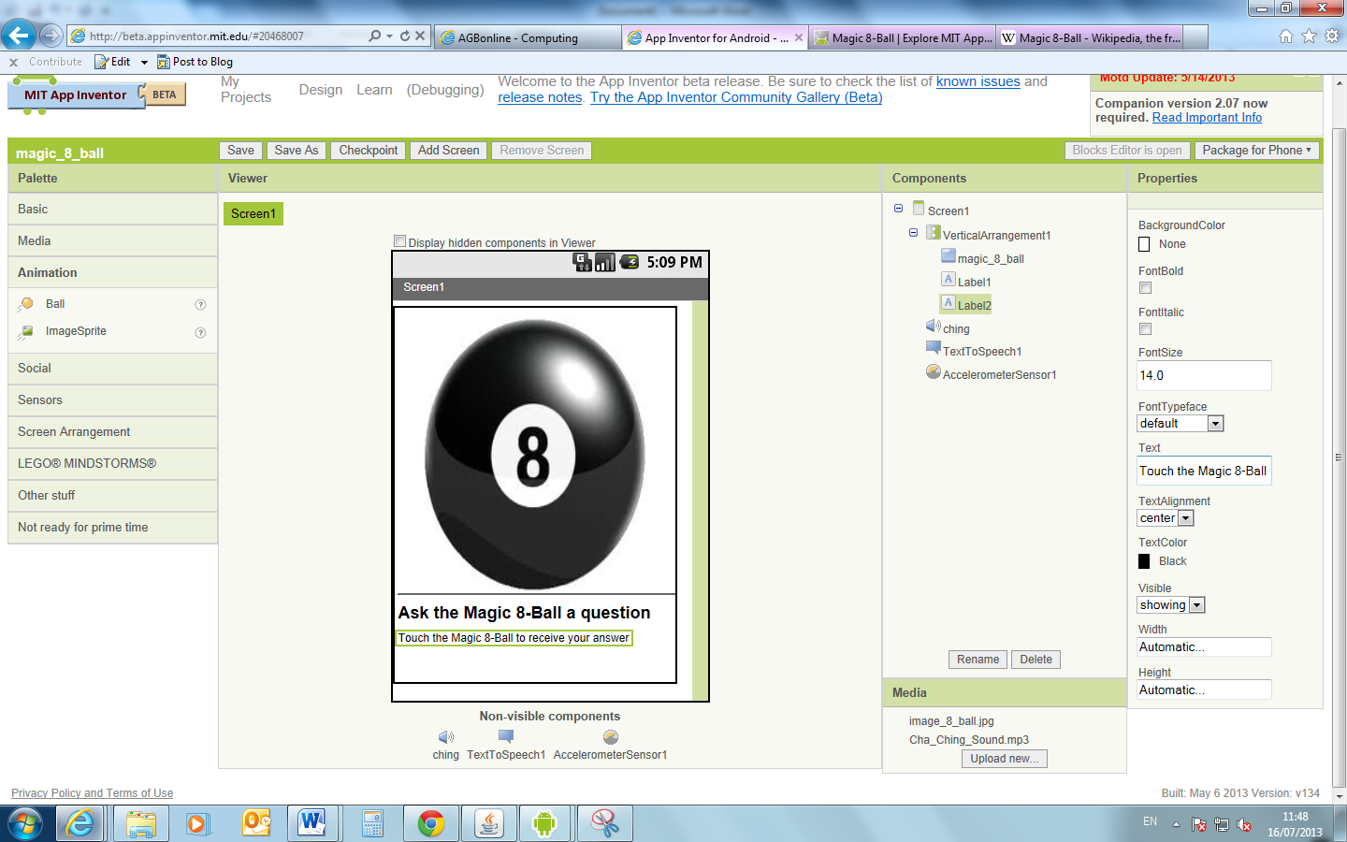

This is the palette to to select the different required things

This is a preview of how the app will appear, things which won’t be in the app such as sound, auto go outside the visibility area

The properties of the different objects are changed here

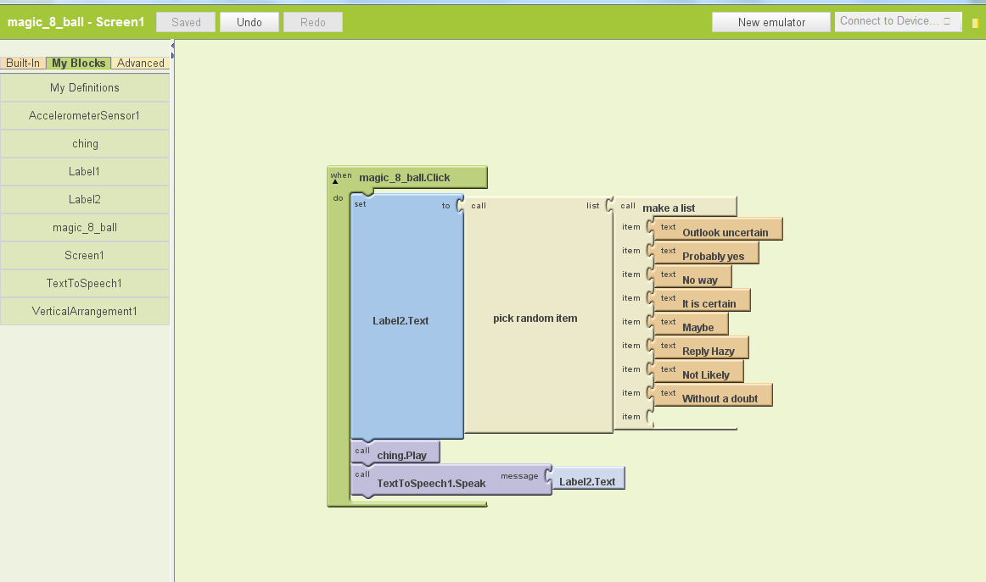

There are different lists that can be chosen from the “built in” option

Label 2 – was the outcome of their question

Makes the text speak out loud – connect the label 2 (all text in label talk will be said out aloud)

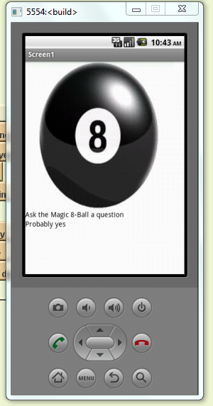

If you ask it a question, it will select an answer at random.

I also created the app called the paint pot, where a colour could be selected to draw line. I then continued on to the advanced task where the thickness of the line was altered.

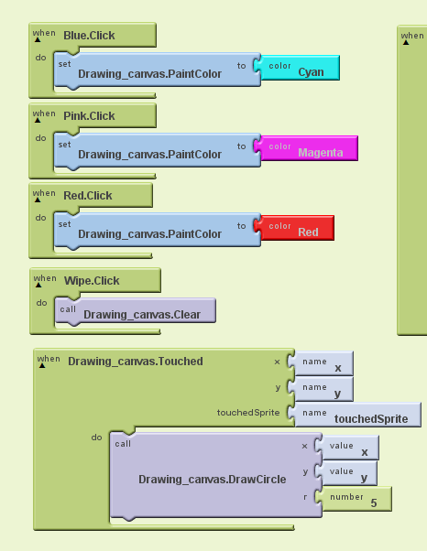

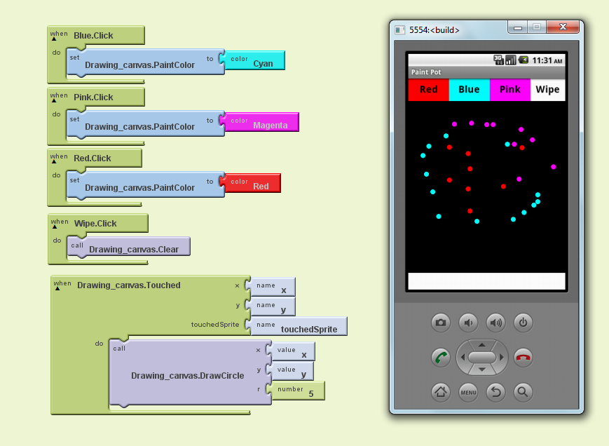

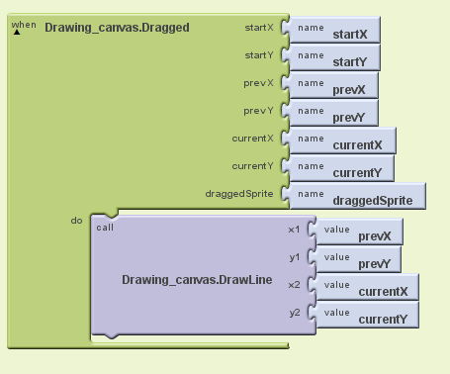

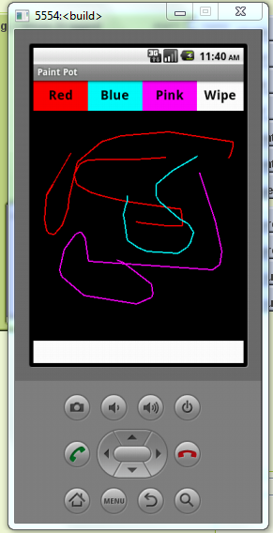

Changing the size of the dot

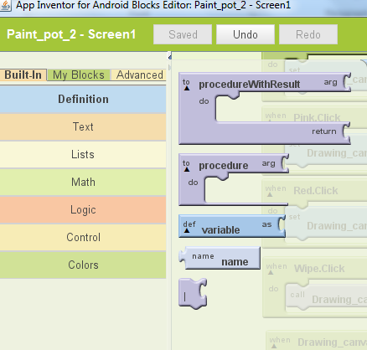

The variable block needs to be selected

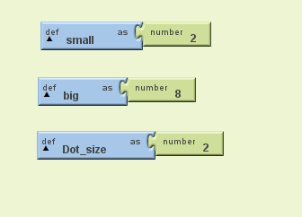

The variables need to be defined, so here, the small one is assigned to number 2, and the big variable is set to 8. The dot size variable is also set to 2.

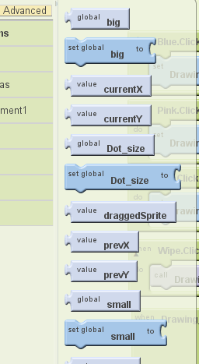

Creating the three variables has made six new blocks in my definitions drawer.

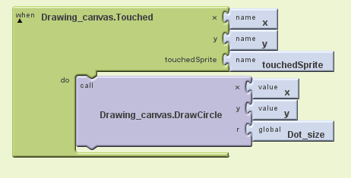

So when the canvas is touched, a circle will be drawn. The radius of number 5 has been replaced by dot size.

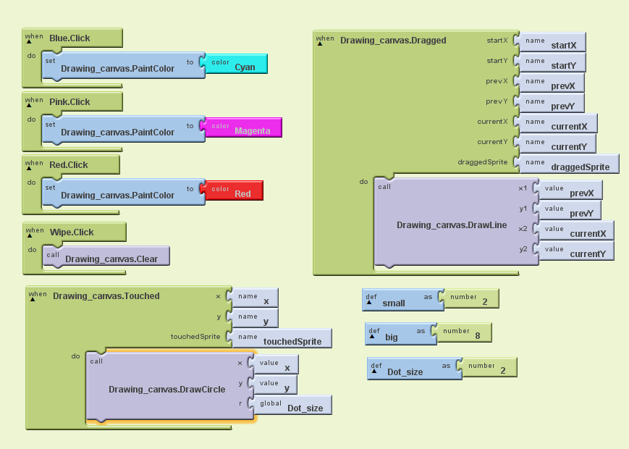

Here the thickness of the line has been changed also the line will be continuous when it is dragged.