**Data Representation**

**Data** – Raw material, words/numbers without a particular meaning or purpse

**Information** – the raw data is used and put into some context

**Knowledge** – Is the understanding taken from the information gathered

**Binary/ denary/ hexadecimal**

Binary - It is a 'base-2' number system - This type of number will only have two digits, a 1 or 0 and is used to represent the two states (ON, OFF) of a computer whilst processing data. The digital data that is known as bits and bytes can also be represented as a binary number.

|  |  |  |  |  |  |  |  |
| --- | --- | --- | --- | --- | --- | --- | --- |
| 128 | 64 | 32 | 16 | 8 | 4 | 2 | 1 |
| 0 | 1 | 0 | 0 | 1 | 0 | 1 | 1 |

Bit - (This is a single binary digit), each bit is represented as a 1 or 0 and is the smallest unit of data that can be stored.

Byte - A byte contains 8 bits, e.g. 10000101. A single character on the keyboard is equivalent to one byte.

Denary – It is a ‘base-10’ number system. This has the number digits 0,1,2,3,4,5,6,7,8 and 9 and is used by humans.

|  |  |  |  |
| --- | --- | --- | --- |
| 1000-103 | 100-102 | 10-101 | 10-100 |
| 4 thousand | 3 hundred | 7 seventy | 5 |

Hexadecimal – Is a ‘base-16’ number system. There are 16 values; the decimal numbers from 10 to 15 are represented with the letters A to F.

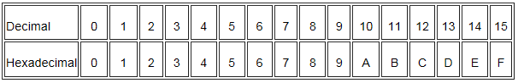

Converting Binary to Denary

|  |  |  |  |  |  |  |  |  |  |
| --- | --- | --- | --- | --- | --- | --- | --- | --- | --- |
| **Binary** | **128** | **64** | **32** | **16** | **8** | **4** | **2** | **1** | **Denary equivalent** |
| 10110101 | 1 | 0 | 1 | 1 | 0 | 1 | 0 | 1 | 128+32+16+4+1=181 |
| 00101111 | 0 | 0 | 1 | 0 | 1 | 1 | 1 | 1 | 32+8+4+2+1=47 |
| 11001011 | 1 | 1 | 0 | 0 | 1 | 0 | 1 | 1 | 128+64+8+2+1=263 |
| 00010011 | 0 | 0 | 0 | 1 | 0 | 0 | 1 | 1 | 16+2+1=19 |

Converting Denary to Binary

|  |  |  |  |  |  |  |  |  |  |
| --- | --- | --- | --- | --- | --- | --- | --- | --- | --- |
| **Number** | **128** | **64** | **32** | **16** | **8** | **4** | **2** | **1** | **Binary equivalent** |
| 115 | 0 | 1 | 1 | 1 | 0 | 0 | 1 | 1 | 01110011 |
| 255 | 1 | 1 | 1 | 1 | 1 | 1 | 1 | 1 | 11111111 |
| 59 | 0 | 0 | 1 | 1 | 1 | 0 | 1 | 1 | 00111011 |
| 131 | 1 | 0 | 0 | 0 | 0 | 0 | 1 | 1 | 10000011 |

## Representing Text

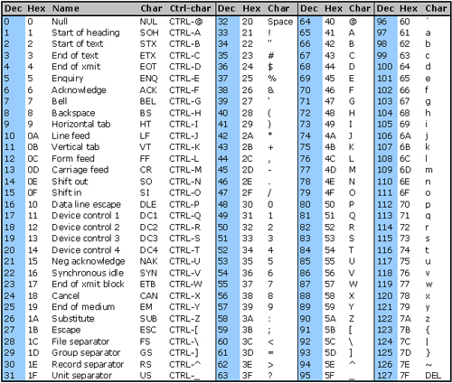To make the passing of data from one computer to another easy, a standard form of representing characters was adopted by computer manufacturers. The American Code for Information Interchange (ASCII).