An algorithm is the plan for writing the program steps required for solving a problem. Algorithm tools include flowcharts and pseudo codes.

**Flowol**

This is a program used in a lot of schools to teach students how to make flowcharts. These flowcharts can be basic and have a basic purpose of affecting one output or complex by controlling outputs simultaneously.

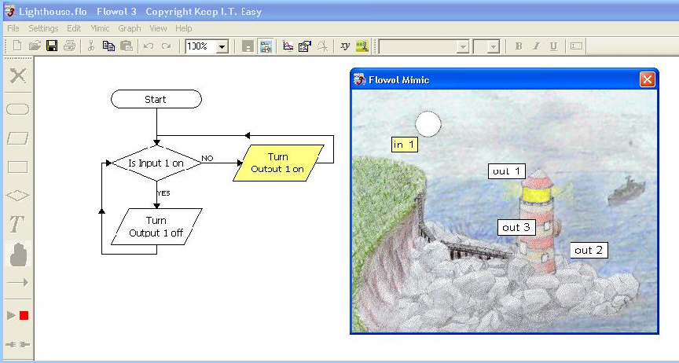

This is a basic loop where when input one is off then the output 1 is on and then when input 1 is on the output 1 turns off.

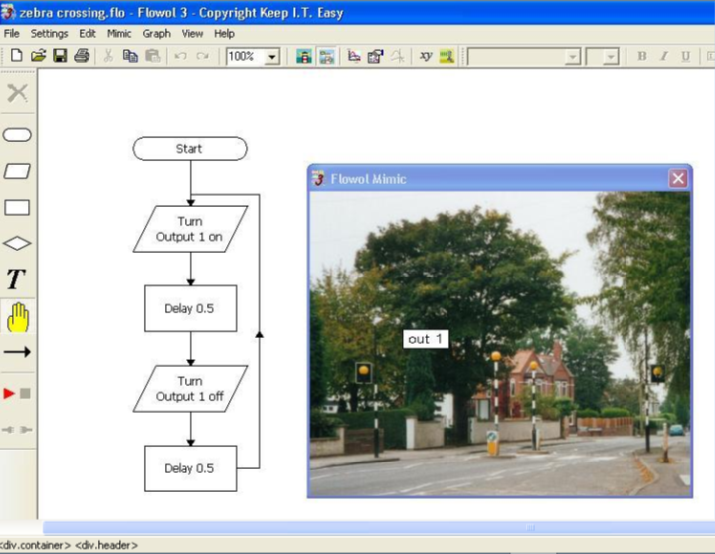

In this example Output 1 are the lights and the first command tells Output 1 to turn on. A delay of 0.5 seconds is inserted before the 'turn Output 1 off' function. This is followed by another delay of 0.5 seconds. This process is then looped so the lights flash continuously on for 0.5 seconds and off for 0.5 seconds.

This is a more complex flowchart:

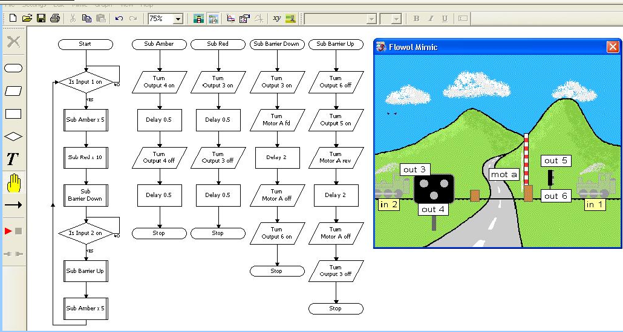

This operates the ferris wheel so when input 1 and input 1 is on the ferris wheel will begin to turn around

This controls a lot of outputs simultaneously such as the barrier, the warning lights for the trains, and warning signal for drivers.

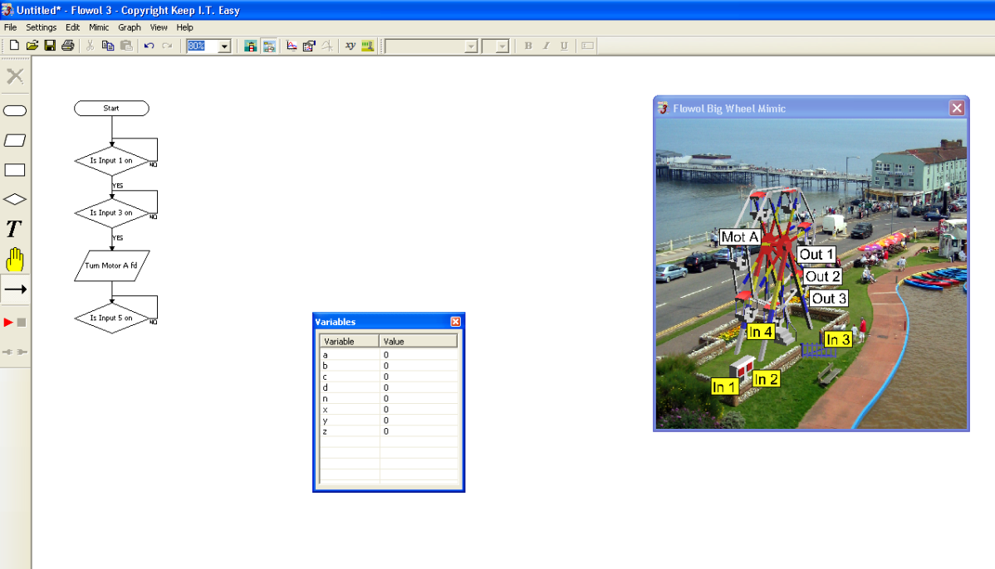

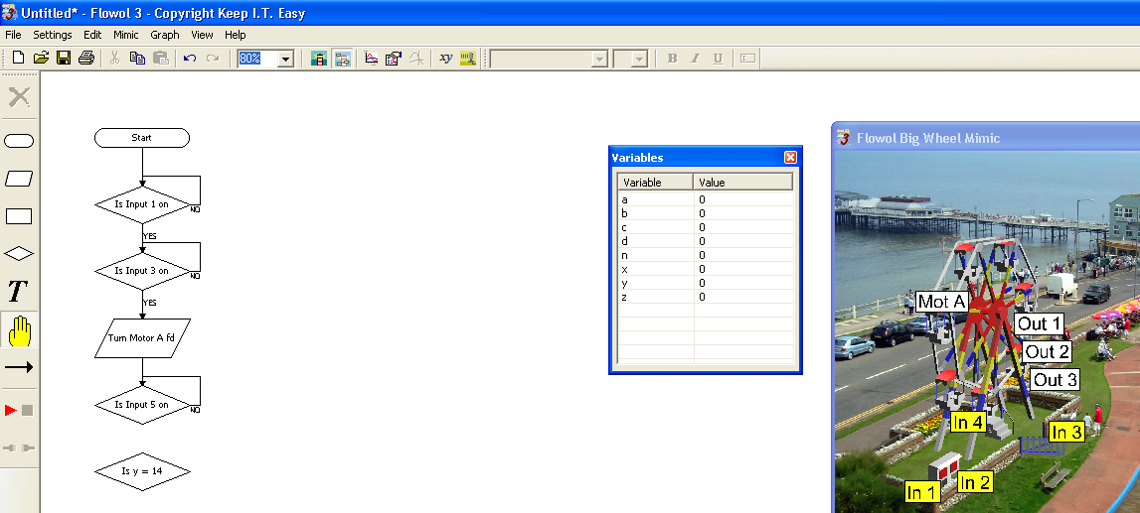

This flowchart stops the ferris wheel after every carriage so every passenger gets the chance to get off it

This flowchart will allow the ferris wheel to go around once and then stop, however some of the passengers will be stuck on the top, so it is not the ideal flowchart

3